# Module – 3

# (Testing on Live Application)

1. **What is RDBMS**

* The software used to store, manage, query, and retrieve data stored in a relational database is called a Relational Database Management System (RDBMS).
* The RDBMS provides an interface between users and applications and the database, as well as administrative functions for managing data storage, access, and performance.
* It is an information management system that is oriented on a data model.
* All the information is properly stored as tables.
* RDBMS is the basis for SQL, and for all modern database systems like MS SQL Server, IBM DB2, Oracle, MySQL, and Microsoft Access,Oracle, MariaDB, and SQLite.

1. **What is SQL**

* SQL stands for Structured Query Language. SQL lets you access and manipulate databases.
* SQL is the standard language for Relational Database System.
* SQL became a standard of the American National Standards Institute (ANSI) in 1986, and of the International Organization for Standardization (ISO) in 1987.
* SQL is Structured Query Language, which is a computer language for storing, manipulating and retrieving data stored in a relational database.
* All the Relational Database Management Systems (RDMS) like like MS SQL Server, IBM DB2, Oracle, MySQL, and Microsoft Access,Oracle, MariaDB, and SQLite use SQL as their standard database language.
* Also, they are using different dialects, such as −
  + MS SQL Server using T-SQL,
  + Oracle using PL/SQL,
  + MS Access version of SQL is called JET SQL (native format) etc.

1. **Write SQL Commands**

* **There are 4 main types of commands:**

1. **DDL** – Data Definition Language

* **CREATE :** Creates a new table,a view of a table, or other object in database.
* **ALTER :** Modifies an existing database object,such as a table.
* **DROP :** Deletes an entire table,a view of a table or other object in the database.

1. **DML** – Data Manipulation Language

* **SELECT :** Retrieves certain records from one or more tables.

1. **DCL** – Data Control Language

* **INSERT :** Creates a record.
* **UPDATE :** Modifies records .
* **DELETE :** Deletes records.

1. **DQL** – Data Query Language

* **GRANT :** Gives a privilege to user.
* **REVOKE :** Takes back privileges granted from user.

1. **What is join?**

* A join is an SQL operation performed to establish a connection between two or more database tables based on matching columns, thereby creating a relationship between the tables.
* Most complex queries in an SQL database management system involve join commands.
* SQL Join statement is used to combine data or rows from two or more tables based on a common field between them.

1. **Write type of joins.**

* **Different types of Joins are as follows:**

1. INNER JOIN
2. LEFT JOIN
3. RIGHT JOIN
4. FULL JOIN
5. **INNER JOIN:** Returns records that have matching values in both tables

**Inner Join**

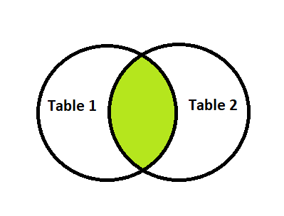

1. **LEFT JOIN:** Returns all records from the left table, and the matched records from the right table

**Left Join**

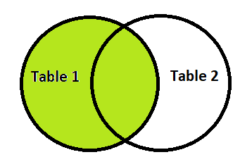

1. **RIGHT JOIN:** Returns all records from the right table, and the matched records from the left table

**Right Join**

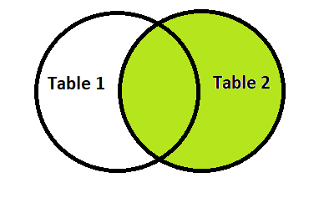

1. **FULL JOIN:** Returns all records when there is a match in either left or right table

**Full Join**

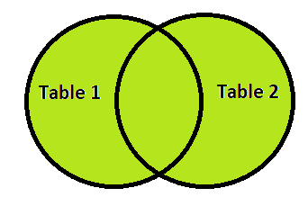

1. **How many constraint and describes itself**

* Constraints and the rules enforced on the data columns of a table. These are used to limit the type of data that can go into a table. This ensures the accuracy and reliability of the data in the database.
* The available constraints in SQL are:

1. **NOT NULL :** Ensures that a column cannot have a NULL value. If a column is specified as NOT NULL then we will not be able to store null in this particular column any more.
2. **UNIQUE :** Ensures that all values in a column are different. The values in any row of a column must not be repeated.
3. **PRIMERY KEY :** A combination of a NOT NULL and UNIQUE. Uniquely identifies each row in a table and this constraint is used to specify a field in a table as primary key.
4. **FOREIGN KEY :** Prevents actions that would destroy links between tables and this constraint is used to specify a field as Foreign key.
5. **CHECK :** Ensures that the values in a column satisfies a specific condition.
6. **DEFAULT :** Sets a default value for a column if no value is specified.
7. **Difference between RDBMS vs DBMS**

|  |  |  |
| --- | --- | --- |
| **No.** | **RDBMS** | **DBMS** |
| **1** | RDBMS stands for Relational Data Base Management System. | DBMS stands for Data Base Management System. |
| **2** | Data is stored as tables. | Data is stored as file. |
| **3** | In RDBMS, multiple data elements can be accessed at same time. | In DBMS, each data elements are to be accessed individually. |
| **4** | Data is present in multiple tables which can be related to each other. | There is no relationship between data in DBMS. |
| **5** | Normalization can be achieved. | Normalization cannot be achieved. |
| **6** | RDBMS supports distributed databases. | DBMS has no support for distributed databases. |
| **7** | RDBMS deals with large quantity of data. | DBMS deals with small quantity of data. |
| **8** | Data Redundancy can be reduced using key and indexes in RDBMS. | Data Redundancy is common in DBMS. |
| **9** | RDBMS supports multiple users at a time. | DBMS supports single user at a time. |
| **10** | RDBMS has multi layer security during data manipulation. | DBMS provides low security during data manipulation. |
| **11** | Example : Oracle, SQL Server. | Example : Ms Access. |

1. **What is API Testing**

* API stands for Application Programming Interface which acts as an intermediate of communication between two applications.
* Two applications talk to each other and performs the required actions efficiently.
* API contains a set of rules and guidelines based on which the applications are developed.
* API acts as an interface between two software applications so that two software applications can communicate with each other.
* API Testing refers to test the APIs which are used in the application just to validate that the APIs are working fine.
* When a system has a collection of APIs, these needs to be tested to know that the system is working perfectly or not.
* Mostly we can say that API testing confirms system’s performance, reliability, security and functionality.
* Testing technique similar to unit testing in that it targets the code level.
* API Testing differs from unit testing in that it is typically a QA task and not a developer task.
* The purpose of API Testing is to check the functionality,reliability,performance, and security of the programming interfaces.
* In API Testing, instead of using standard user inputs(keyboard) and outputs, you use software to send calls to the API, get output, and note down the system’s response.
* API tests are very different from GUI Tests and won’t concentrate on the look and feel of an application.

1. **Types of API Testing**

* There are mainly 3 types of API Testing :
  + **Open APIs :** These types of APIs are publicly available to use like O Auth APIs from Google. It has also not given any restriction to use them. So, they are also known as Public, APIs.
  + **Partner APIs :** Specific rights or licenses to access this type of API because they are not available to the public.
  + **Internal APIs:** Internal or private. These APIs are developed by companies to use in their internal systems. It helps you to enhance the productivity of your teams.

1. **What is Responsive Testing?**

* Responsive testing is a process that renders web pages on view ports of multiple devices using CSS media queries based on the user device where the website is accessed.
* Responsive testing ensures how responsive web design is optimized well for all types of screen sizes and resolutions.
* Responsive testing aims to ensure that the same website looks great on any screen size so its usability is consistent across all device types.
* A responsive web design improves users’ browsing experience. Considering this from a quality assurance perspective,a responsive web design requires thorough evaluation using a variety of devices before it is ready to go live.

1. **Which types of tools are available for Responsive Testing**

* **Responsive Testing Tools :**

1. LT Browser
2. Lembda Testing
3. Google Resizer
4. I am responsive
5. Pixel tuner
6. **What is the full form of .ipa, .apk**

* **iPA :** iOS APP Store Package.
* **APK :** Android Application Package file.

1. **How to create step for to open the developer option mode ON?**

* Steps for open the developer option mode ON :
  + First navigate to open settings.
  + Tap to Open About Phone
  + To enable Developer mode, rapidly tap Build number.
  + A pop up message “ You are now a Developer!”
  + Select Developer options mode
  + USB Debugging mode ON
  + The Developer options will be activated; you can now access it at the very bottom of the main Settings menu.
  + Click OK on “Allow USB debugging?”